**Warriors TRIAL**

**An Apocalypse has erupted from an alien race coming through portals. It’s up to you, your magic sword is our only hope to stop the horde from destroying our homeland!**

**Core Mechanics**

* Combo melee attacks, - didn’t make-super attacks (animation cooldowns)
* Movement, dashing and jumping
* Reach the portal to destroy it. (triggers restart or next level)
* Kill all horde members before time runs out.
* Enemies melee attack and charge at player
* Making your Personal Best High score- (UI)

**Gameplay**

The player must reach the portal within the time frame given, killing consecutive enemies hitting combo counters will restore time as the enemy will ne time to respawn. Its will be up to the player to use certain strategies to clump enemies together to hit combos while balancing not dying and cooldowns for super moves.

**Art style**: third person action like the fable series, Dmc: Devil may cry (2013) and Darksiders (2010)

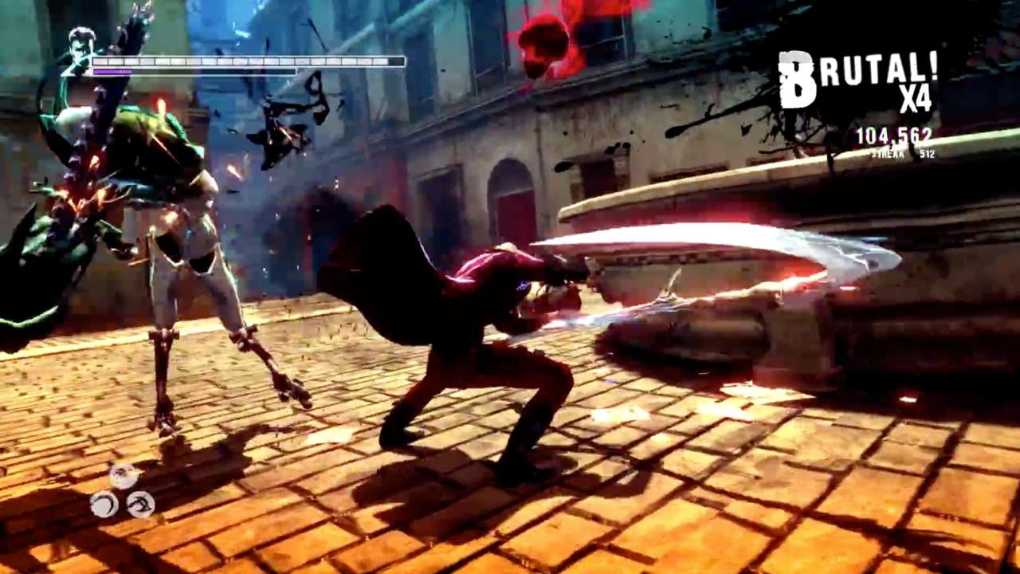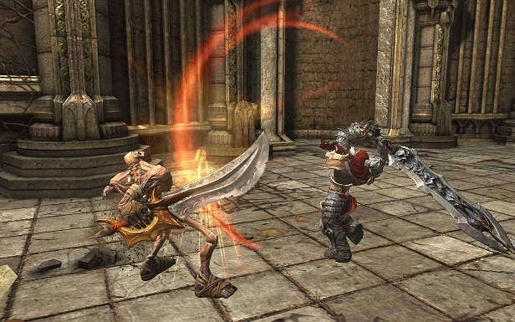

RED = didn’t make happen, But as I did not state in the previous 1 pager what the MVP was, I think I did meet what I discussed